Website Introduction: Structure & Components, WordPress Overview
1. Food-delivery website sitemap
- Home: Main landing page with offers, popular restaurants and search.
- Menu: Food categories such as pizza, biryani, burgers and desserts.
- Restaurant Details: Restaurant menu, ratings, delivery time and food items.
- Cart: Selected food items, quantity, address and payment.
- Profile: User details, saved addresses and order history.
- Contact Us: Help, customer support and feedback form.
2. Five homepage components of an e-commerce website like Flipkart
Component | Purpose
Navigation bar | Helps users move to categories such as Electronics, Fashion, Grocery and Home.
Search bar | Lets customers quickly search for products, brands or categories.
Banner / hero section | Promotes sales, festive offers, new launches and discount campaigns.
Product grid | Displays products with images, prices, ratings and discounts.
Footer | Contains useful links such as About Us, Contact, Help Centre, Terms and Privacy Policy.
3. Create a free WordPress site
Home: Main landing page with offers, popular restaurants and search.
Menu: Food categories such as pizza, biryani, burgers and desserts.
Restaurant Details: Restaurant menu, ratings, delivery time and food items.
Cart: Selected food items, quantity, address and payment.
Profile: User details, saved addresses and order history.
Contact Us: Help, customer support and feedback form.
2. Five homepage components of an e-commerce website like Flipkart
Component Purpose
Navigation bar Helps users move to categories such as Electronics, Fashion, Grocery and Home.
Search bar Lets customers quickly search for products, brands or categories.
Banner / hero section Promotes sales, festive offers, new launches and discount campaigns.
Product grid Displays products with images, prices, ratings and discounts.
Footer Contains useful links such as About Us, Contact, Help Centre, Terms and Privacy Policy.

3. Create a free WordPress site
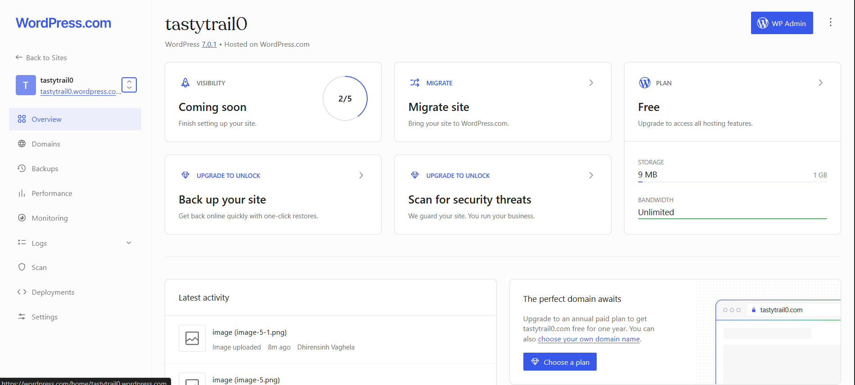
4. Create the “Upcoming Events” page
